**Computer Networks**

**CS330**

**Chapter 5 Assignment**

Q1\ Consider the scenario below in which three hosts, with private IP addresses 10.0.1.12, 10.0.1.17, 10.0.1.19 are in a local network behind a NAT'd router that sits between these three hosts and the larger Internet. IP datagrams being sent from, or destined to, these three hosts must pass through this NAT router. The router’s interface on the LAN side has IP address 10.0.1.28, while the router’s address on the Internet side has IP address 135.122.202.216.

Suppose that the host with IP address 10.0.1.17 sends an IP datagram destined to web server 128.119.173.182. The source port is 3454. ***(hint: the port number used for web server is 80)***

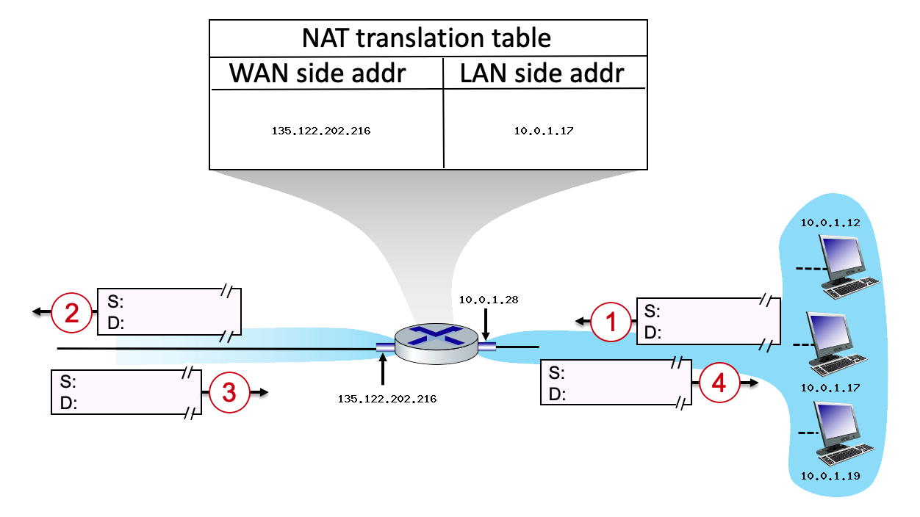

Show the source [IP address, port number] and destination [IP address, port number] for request and response messages inside and outside the NAT.

|  |  |  |
| --- | --- | --- |
| **Datagram#** | **Source [IP address, port number]** | **Destination [IP address, port number]** |
| 1 |  |  |
| 2 |  |  |
| 3 |  |  |
| 4 |  |  |

Q2\ An organization is granted the block **192.16.0.0/26**. The administrator wants to create **2** subnets. (**note: the IP addresses in this question must be written in dotted decimal notation)**

1. Find the subnet mask?
2. Find the total number of IP addresses in each subnet?

1. Find the number of hosts in each subnet?

1. For each subnet in the table below find the following:

|  |  |  |
| --- | --- | --- |
| **Subnet** | **Subnet 1** | **Subnet 2** |
| **Network IP Address** |  |  |
| **Broadcast address** |  |  |
| **Address of the first host** |  |  |
| **Adress of the last host** |  |  |

Q3\ An organization is granted the block **192.16.0.0/20**. The administrator wants to create **4** subnets. (**note: the IP addresses in this question must be written in dotted decimal notation)**

1. Find the subnet mask?
2. Find the total number of IP addresses in each subnet?

1. Find the number of hosts in each subnet?

1. For each subnet in the table below find the following:

| **Subnet#** | **Start Address** | **End Address** | **Broadcast Address** |
| --- | --- | --- | --- |
|  |  |  |  |
|  |  |  |  |
|  |  |  |  |
|  |  |  |  |

Q4\ What fields present in the IPv4 header have been removed in the IPv6 header, and why were they removed?

Q5\ **Using the link state protocol (Dijkstra’s algorithm),**

1. Find the least-cost paths from **Node E** to all possible destinations in the following network. Assume that the cost of a link is the same in both directions



|  |  |  |  |  |  |  |  |
| --- | --- | --- | --- | --- | --- | --- | --- |
| Step# | N’ | A | B | C | D | F | S |
|  |  |  |  |  |  |  |  |
|  |  |  |  |  |  |  |  |
|  |  |  |  |  |  |  |  |
|  |  |  |  |  |  |  |  |
|  |  |  |  |  |  |  |  |
|  |  |  |  |  |  |  |  |
|  |  |  |  |  |  |  |  |

b. Construct the least cost path tree and forwarding table for **Node E**.